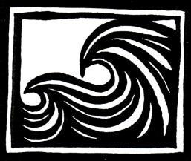
CAREN LOEBEL-FRIED
Artist/Author
Mobile: 551-206-6325
Email: contact@carenloebelfried.com
Web: www.carenloebelfried.com

23 November 2022
Nudibranchs, art created for Pacific Beach Coalition
Nudibranchs, featuring an Opalescent Nudibranch and Orange-peel Doris is a hand-pulled, hand-colored block print by Caren Loebel-Fried.
Featured in the art are Bay Area sea slugs known as nudibranchs, which live in the rocky tidepools along the coast. The larger one is an Opalescent Nudibranch and is lying on a bed of seagrass near its egg sac on the bottom left. On the top right is an Orange Peel Doris, which has exposed gills that inspired the name nudibranch, meaning naked-lung. The two nudibranchs are separated by anemones, which they feed on, along with hydroids, illustrated in the borders, both of which have stinging cells used for defense. Some nudibranchs can steal the stinging cells and use them for their own protection against predators. Nudibranchs don’t see well, but instead of relying on their eyes, they use the antennae-like projections on their head to detect chemicals that help them find food and mates. There are many ways to help sea slugs, including making beautiful artwork like this, which helps educate and inspire those who see it.

